Comprehensive Architectural Analysis of YOLOv8
YOLOv8, engineered by Ultralytics, represents a major structural evolution in the You Only Look Once (YOLO) lineage of real-time object detectors. By entirely abandoning the traditional anchor-based paradigm in favor of an anchor-free, decoupled architecture, it achieves a highly optimized balance between computational efficiency and state-of-the-art accuracy.
This report provides an in-depth dissection of the YOLOv8 architecture, broken down into its three foundational pillars: the Backbone, the Neck, and the Head, along with its modern loss functions and label assignment strategies.
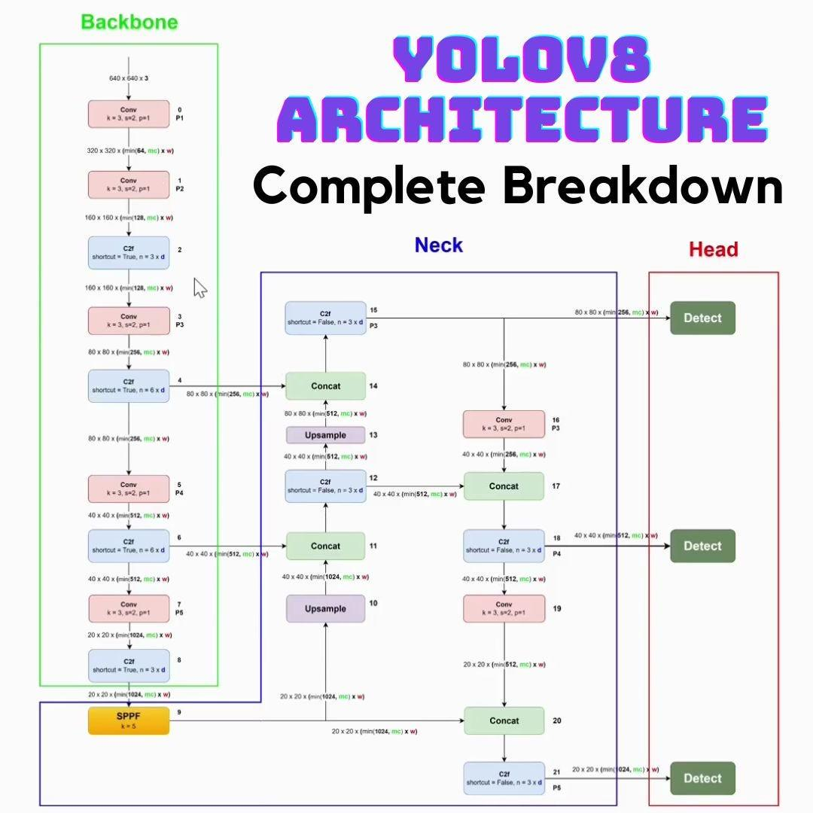
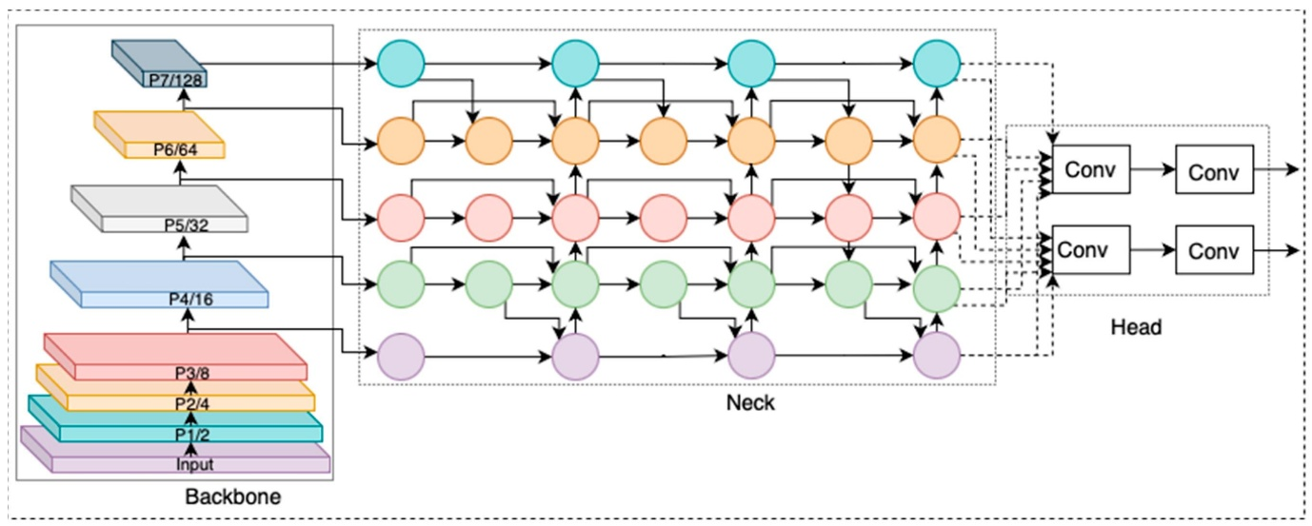
[Insert Figure 1: High-Level YOLOv8 Architecture Overview Diagram]
1. The Backbone: Advanced Feature Extraction
The backbone is the primary feature extractor of the network, responsible for transforming raw input pixels into rich, hierarchical feature maps. YOLOv8 utilizes a heavily modified version of the CSPDarknet architecture.
The C2f Module (Cross Stage Partial Bottleneck with 2 Convolutions)
The most significant architectural shift in the YOLOv8 backbone is the replacement of the older C3 block (used in YOLOv5) with the newly designed C2f block.
- Structural Mechanics: In the older C3 block, the input tensor was split, passed through a bottleneck, and then concatenated. The C2f module refines this by routing the output of the initial convolution directly into multiple parallel bottleneck sequences.
- Gradient Flow: Instead of only concatenating the final output of the bottleneck chain, the C2f block concatenates the intermediate outputs of every single bottleneck within the sequence. This dense connection drastically improves the gradient flow during backpropagation, allowing the network to capture richer, more nuanced semantic information without a massive increase in parameter count.
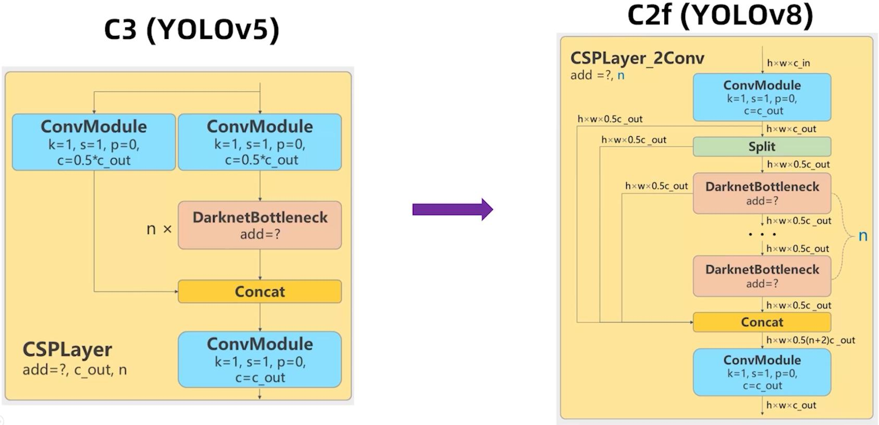
[Insert Figure 2: Structural Comparison of the C3 Module vs. the C2f Module]
Spatial Pyramid Pooling - Fast (SPPF)
At the terminal end of the backbone, YOLOv8 retains the SPPF module. Rather than using large, parallel max-pooling layers (which are computationally expensive), SPPF passes the feature map through three sequential 5×5 max-pooling operations. By concatenating the outputs of these sequential layers, the network effectively achieves a massive global receptive field (equivalent to a 13×13 pooling operation) while requiring less than half the computational floating-point operations (FLOPs).

2. The Neck: Semantic and Spatial Aggregation
The neck acts as the intermediary fusion center. Its role is to aggregate the deep, highly semantic feature maps (which understand what the object is) with the shallow, high-resolution spatial feature maps (which understand where the object is).
PANet (Path Aggregation Network) Architecture
YOLOv8 utilizes a modified PANet structure, which features both a top-down pathway and a bottom-up pathway.
- Top-Down FPN (Feature Pyramid Network): Upsamples the deep, low-resolution features from the end of the backbone and fuses them with mid-level features.
- Bottom-Up PAN: Takes these fused features and downsamples them, passing the spatial information back up the chain.
- Architectural Tweaks: Unlike YOLOv5, YOLOv8 specifically removes the $1 \times 1$ convolutional layers that previously existed right before the upsampling stages. Furthermore, the neck exclusively utilizes the new C2f blocks for feature fusion, which accelerates the aggregation process and maintains a lightweight computational footprint.
[Insert Figure 3: Detailed PANet Feature Aggregation Flowchart]
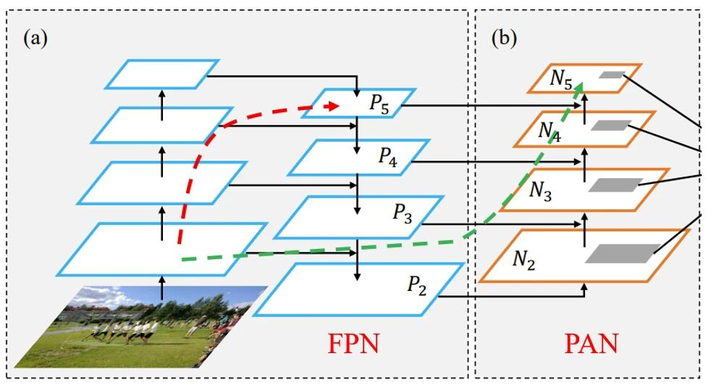
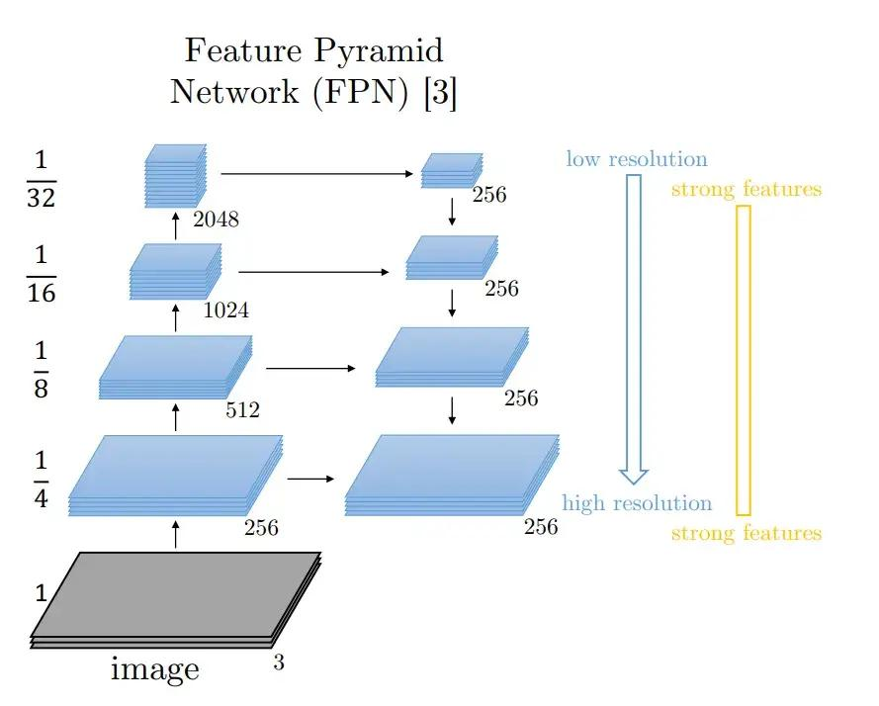

3. The Head: Anchor-Free & Decoupled Predictions
The head of the network is where the mathematical predictions for object boundaries and class labels are generated. This is where YOLOv8 diverges most aggressively from its predecessors.
The Decoupled Head Structure
Historically, models like YOLOv5 used a "coupled head," where a single convolutional branch predicted the class score, the bounding box coordinates, and the objectness score simultaneously. This often led to task conflict, as the mathematical features required to classify an object are vastly different from the spatial features required to draw a tight box around it.
YOLOv8 solves this by implementing a Decoupled Head. The feature map is split into two completely separate neural branches:
- Classification Branch: Focuses entirely on predicting the class probability distribution.
- Regression Branch: Focuses entirely on predicting the physical bounding box coordinates.
Note: YOLOv8 completely removes the "Objectness" (Confidence) branch. The model now treats the highest class probability directly as the confidence score.
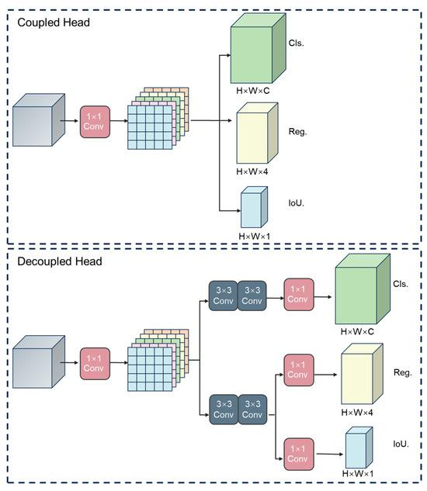
[Insert Figure 4: Mathematical Data Flow in Coupled vs. Decoupled Head Architectures]
Anchor-Free Formulation
YOLOv8 abandons predetermined "anchor boxes" (rigid, predefined box shapes). Instead, it operates as a center-based, anchor-free detector. It treats the center of an object as a positive sample and directly predicts the distance from that center point to the top, bottom, left, and right edges of the bounding box. This morphological flexibility makes YOLOv8 exceptionally proficient at detecting irregularly shaped objects and drastically reduces the number of heuristic hyperparameter tuning required prior to training.

4. Label Assignment and Loss Functions
To train this decoupled, anchor-free architecture, YOLOv8 overhauls its loss calculation mechanisms.
Task-Aligned Assigner (TAL)
Because there are no anchor boxes to match against ground truth labels, YOLOv8 uses dynamic label assignment. The Task-Aligned Assigner calculates a dynamic alignment metric based on a combination of the classification score and the Intersection over Union (IoU) of the predicted box. This ensures that the network prioritizes learning from bounding boxes that are both spatially accurate and correctly classified.
Distribution Focal Loss (DFL) & CIoU
For the bounding box regression branch, YOLOv8 utilizes Complete IoU (CIoU) loss to handle overlapping boxes and aspect ratios. More importantly, it introduces Distribution Focal Loss (DFL).
Traditional models treat the edges of a bounding box as rigid, absolute pixel coordinates. However, in real-world data (especially blurry or occluded images), the exact edge of an object is ambiguous. DFL solves this by treating the continuous bounding box coordinate $y$ as a discrete probability distribution. The loss forces the network to assign high probabilities to the discrete values immediately surrounding the true coordinate:
$$DFL(S_i, S_{i+1}) = -((y_{i+1} - y) \log(S_i) + (y - y_i) \log(S_{i+1}))$$
Where $S_i$ and $S_{i+1}$ represent the network's predicted probabilities for the discrete locations $y_i$ and $y_{i+1}$ that bracket the ground truth continuous label $y$. This mathematical flexibility allows the network to effectively capture the uncertainty of blurry object boundaries, leading to significantly tighter and more accurate bounding boxes.
For the classification branch, standard Binary Cross-Entropy (BCE) loss is utilized to calculate the error of the predicted class probabilities.
Conclusion
The YOLOv8 architecture achieves its state-of-the-art status not through a single monolithic change, but through a series of highly calculated modular upgrades. By transitioning to a C2f-driven backbone for richer gradient flow, deploying a decoupled head to eliminate task conflict, and embracing an anchor-free paradigm with Distribution Focal Loss, YOLOv8 establishes a highly resilient, mathematically flexible framework capable of adapting to highly complex computer vision tasks.

